Instructions (with pictures) for reviewing or updating parent consents are below if needed.

Log into myStudent parent portal (log in instructions are attached).

**Step 1:**

Once on the portal, click the 3 lines at the top right hand corner:

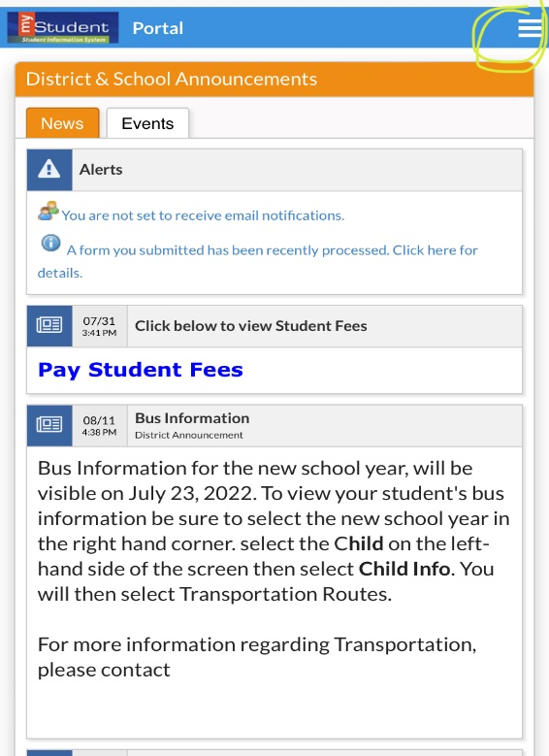

Step 2:

Click “Forms summary” at the bottom left.  (Your child’s name & photo will be shown but are redacted in this example)

Step 3:

Click “Parent/Guardian Consent Form”  
________________________________

Step 4:  
This will take you to the Parent/Guardian Consent form page.  Select “Next page” toward the bottom of the screen to continue through each consent option

Step 5:

Review the consent topic, then scroll to the bottom of the page.

Select “yes” or “no” from the drop down list,  then click “next page” to go to the next consent topic.

Repeat Step 5 for all consent topics, then save.

More instructions and a video can be found [at this link](https://www.pasco.k12.fl.us/oll_documents/parent-bill-of-rights).